Dear Colleagues,
Below is an initial snapshot of media coverage of the Heart-2 study results. Overall, media viewed the results as promising early evidence that a single treatment with VERVE-102 may deliver lasting cholesterol reduction.
A full pulse report on media and digital coverage will follow later this week. Paywalled full text articles are attached.
Coverage Takeaways
- Coverage was centered on the potential impact of VERVE-102. 91% of outlets captured the one-and-done treatment and durability messages, and majority of news coverage was neutral-to-positive, reinforcing that media viewed the results as credible and encouraging early-stage data rather than overstated.
- Media primarily focused on the potential for one infusion of VERVE-102 to deliver lasting cholesterol reduction with New York Times noting “treatment dramatically lowered cholesterol levels, perhaps permanently, after just one infusion.” BBC reported, “it could mean that in the future people may need fewer cholesterol-lowering medicines such as statins.” The Pharma Letter reported, “The appeal of VERVE-102 is not just its target, but its dosing ambition.”
- Media also added to the high anticipation for the Phase 2 trial, with Fierce Biotech stating, “Lilly is laying the groundwork for a phase 2 trial… with the candidate now showing strong and consistent cholesterol reductions after a higher dosing regimen.”
Key Message Pull Through
- 91% Results showed encouraging evidence for VERVE-102 to be a one-time treatment
- 91% VERVE-102 is designed to durably turn off the PCSK9 gene
- 91% Lilly plans to begin enrolling the Phase 2 clinical study
- 32% VERVE-102 is designed to mimic the protective effect of naturally occurring loss-of-function variants in PCSK9
Sentiment Analysis
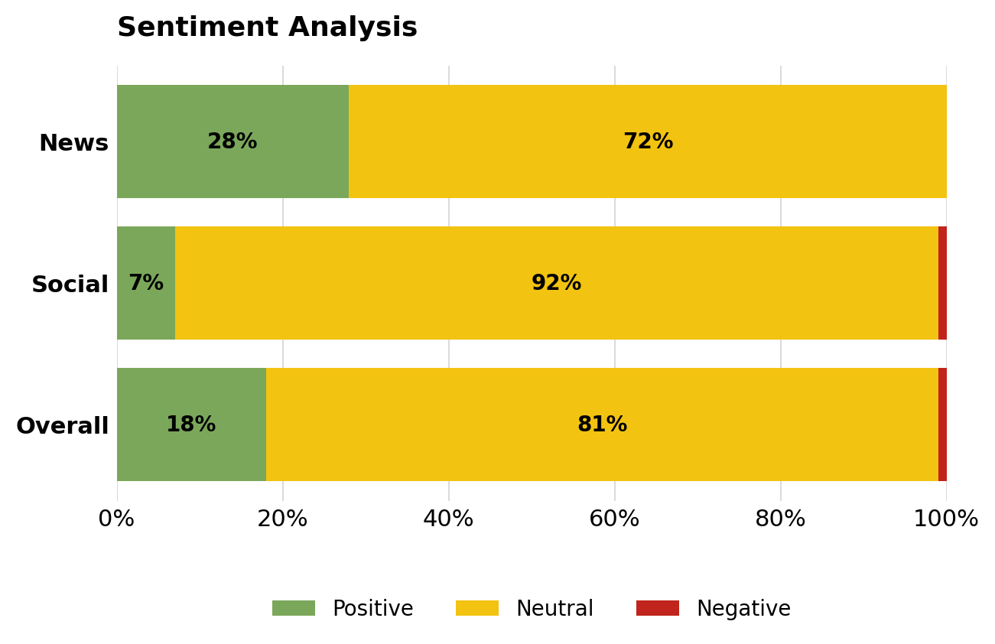
Type of Coverage by Reach
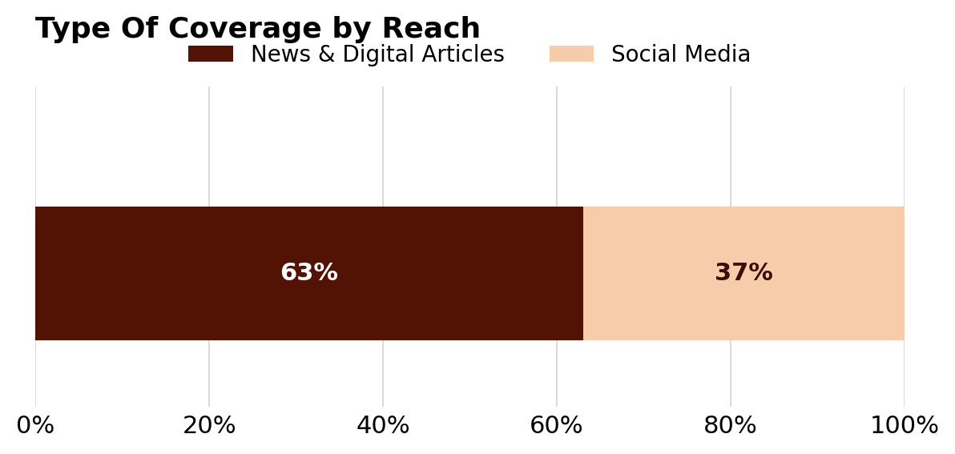
Social Media Volume Breakdown
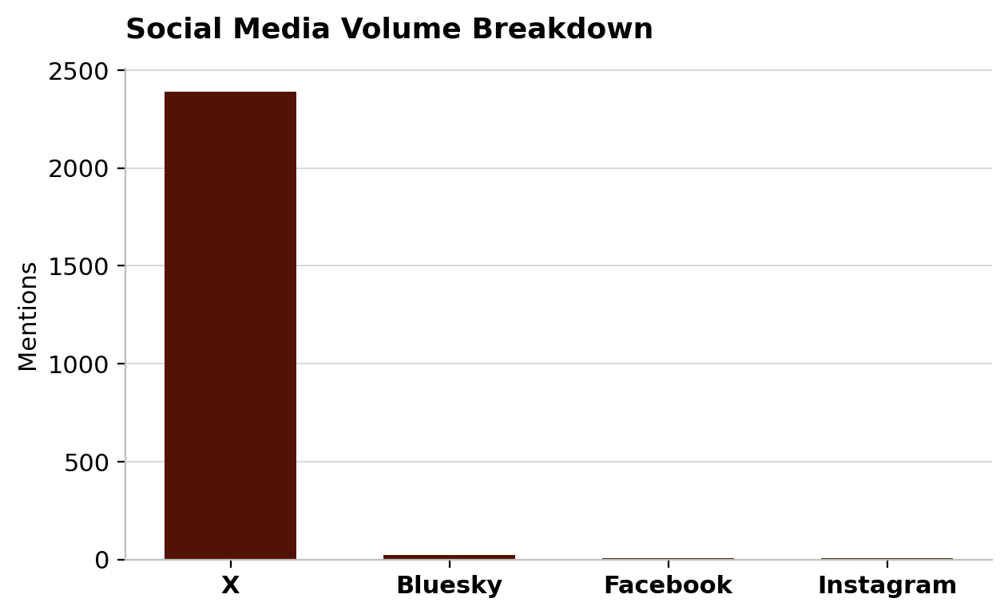
Top News
The coverage below reflects a snapshot of the highest-impact publications within each media tier based on reach; it is not exhaustive.
Top Tier
- New York Times: One-and-Done Heart Disease Prevention? Scientists Show It May Be Possible
- BBC News Broadcast: BBC News at Six
- BBC Radio: Six O'Clock News
Investor Influence
- Dow Jones Newswires: Eli Lilly Reports Positive Early Results for Gene-Editing Cholesterol Therapy
- Barron’s: Lilly Advances Gene Therapy, Snaps Up Vaccine Makers. It’s Looking Beyond Weight Loss
Industry/General Trade & Policy
- FirstWord Pharma: New data bolster Lilly's bet on Verve-developed PCSK9 editor
- STAT News: Eli Lilly says Verve’s gene editor lowers cholesterol levels in early study
- Fierce Biotech: Lilly preps for ph. 2 launch after Verve gene editor cuts cholesterol on par with PCSK9 inhibitors
- Scrip: Lilly Plans Phase II For VERVE-102 Gene-Editing Therapy After Early LDL-C Data
- Endpoints News: Lilly reports new data on PCSK9 base editing gene therapy from Verve buyout
- BioPharma Dive: Early data for heart drug affirm Lilly’s billion-dollar bet on Verve
- The Pharma Letter: Lilly’s one-shot cholesterol drug raises the stakes
- BioSpace: Lilly’s Verve gambit pays off as base editor cuts cholesterol in early study
- BioSpace: Lilly reports positive interim results from Heart-2 trial of VERVE-102
General Population
- Daily Mail: One-and-done injection can slash 'bad' cholesterol by 60 per cent, according to new study
- New York Post: ‘Revolutionary’ new treatment can lower bad cholesterol by up to 62% — with just one dose
OUSA/Global Media
- La Vanguardia (Spain): RNA therapy reduces cholesterol lastingly with a single dose
- Business Standard (India): Can one treatment lower cholesterol and reduce heart attack risk for years?
- News18 (India): Could Gene Editing Change Heart Disease Treatment? Eli Lilly’s Early Data Looks Promising

